Disease Prediction System Using Machine Learning: A Comparative Study of Classification Algorithms for Symptom-Based Screening
M Sai Shashank  Department of Computer Science and Engineering  Koneru Lakshmaiah Education  Hyderabad, India  2420030210@klh.edu.in | P Venkata Sai Charan  Department of Computer Science and Engineering  Koneru Lakshmaiah Education  Hyderabad, India  2420030339@klh.edu.in | P Pardhasaradhi  Department of Computer Science and Engineering  Koneru Lakshmaiah Education  Hyderabad, India  2420030088@klh.edu.in
Dr. N. Sunanda
Associate Professor
Department of Computer Science and Engineering
Koneru Lakshmaiah Education
Hyderabad, India

Abstract—Early and accurate detection of diseases is critical for effective treatment and for reducing the burden on healthcare systems. This paper presents a Disease Prediction System that uses machine learning to predict the most probable disease from the symptoms and clinical parameters supplied by a user. The system collects patient data, performs cleaning and feature selection, and trains and compares four supervised classifiers: decision tree, random forest, k-nearest neighbours (KNN), and naive Bayes. The models are evaluated using accuracy, precision, recall, and F1-score on a held-out test set. Random forest performed best, reaching 92.33% accuracy and a 92.36% F1-score, and it is deployed behind a simple user interface that returns a predicted disease along with a confidence score. The proposed system is intended to support, and not replace, clinical judgment by providing quick preliminary screening. The modular architecture is scalable and can be extended to additional diseases and datasets.
Keywords—disease prediction, machine learning, healthcare, classification, symptom analysis, random forest, system architecture

I. Introduction
Diseases that are detected late are harder and costlier to treat, and in many regions patients have limited access to specialist consultation. In large and densely populated countries, a single physician may be responsible for hundreds of patients every day, and people in smaller towns and rural areas often travel long distances before they can be examined. As a result, early warning signs are frequently ignored, and conditions that could have been managed with simple treatment progress to a stage that demands expensive and prolonged care. Any tool that helps people recognise a likely problem sooner and decide when to seek a consultation can therefore make a real difference.
Recent growth in digital health records and advances in machine learning have made it practical to build data-driven tools that screen for disease from routine information such as symptoms, vital signs, and laboratory values [6]. Machine learning algorithms learn patterns from past cases in which the symptoms and the confirmed diagnosis are both known, and they can then apply what they have learned to a new patient. A disease prediction system uses such data to estimate which condition a patient is most likely to have, allowing earlier consultation and better use of clinical resources [13], [14].
Developing such a system raises several practical questions. Which algorithm gives the most reliable predictions on symptom data? How should the raw data be cleaned and encoded so that the model can use it? How can the output be presented so that a non-expert user understands how much trust to place in it? And how can the software be organised so that it can be retrained when new data becomes available? This work addresses these questions by building a complete, modular pipeline and by comparing several well-known classifiers under identical conditions.
This paper presents a Disease Prediction System that accepts symptoms and clinical parameters as input and returns a predicted disease together with a confidence score. The main objectives of the work are:
- to collect and prepare a labelled dataset of symptoms and diseases for supervised learning;
- to train several classification models and compare them using accuracy, precision, recall, and F1-score;
- to select the best-performing model and store it so that predictions can be served without retraining;
- to provide a simple interface that reports the predicted disease together with a confidence score; and
- to design the system as independent modules so that it can be extended to more diseases and larger datasets.
The main contributions of this work are: (1) a complete pipeline covering data preprocessing, feature selection, model training, and evaluation; (2) a layered system architecture that separates the offline training phase from the online prediction phase; (3) a comparison of several supervised classifiers on the same data; and (4) a simple interface through which users can obtain predictions. The system is meant for preliminary screening and does not replace a qualified medical professional.
The rest of the paper is organized as follows. Section II reviews related work, Section III describes the proposed system and its architecture, Section IV explains the implementation, Section V discusses the results, Section VI concludes the paper, and Section VII outlines the future scope of the work.

II. Related Work

A. Machine Learning for Disease Diagnosis
Machine learning has been applied to the diagnosis of a wide range of conditions, including diabetes, heart disease, and cancer. Early work relied on simple models such as decision trees [8], which learn a set of if-then rules from the data and are easy for clinicians to read. Tree-based ensembles such as random forests [1] and gradient boosting [2] are now popular for tabular clinical data because they handle mixed feature types and capture non-linear relationships, while support vector machines [4] remain effective on smaller datasets. Deep learning has shown strong results mainly where large volumes of images or records are available [6], [15].
Instance-based methods such as the k-nearest neighbour rule [7] make predictions by comparing a new patient with the most similar past cases, which matches the way clinicians often reason by analogy. Probabilistic classifiers such as naive Bayes [9] are attractive because they are fast, need little training data, and directly provide class probabilities, even though their assumption of independent features is rarely true for real symptoms. Surveys of the field [13], [14] note that no single algorithm is best for all problems, so a fair comparison on the dataset at hand is the sensible way to choose a model.

B. Class Imbalance and Evaluation
Medical datasets are usually imbalanced because common diseases have many more records than rare ones. A classifier trained on such data can reach a high overall accuracy simply by favouring the common classes. Two families of remedies are widely used: giving higher weights to under-represented classes during training, and resampling the data, for example with the synthetic minority oversampling technique (SMOTE) [10]. For evaluation, accuracy alone is not enough; precision, recall, and F1-score give a more complete picture of how each class is handled [12], and cross-validation [11] gives a more stable estimate of performance than a single split.

C. Explainability and Trust
Clinicians and patients are reluctant to rely on a prediction they cannot understand. Model-agnostic explanation methods such as LIME [17] and SHAP [16] address this by showing which input features pushed a prediction towards a given class. Reporting a confidence score with each prediction is a simpler but useful step in the same direction, because it tells the user whether the model is sure or uncertain about its answer.

D. Limitations of Existing Systems
Many existing tools are built for a single disease, require laboratory data that is not always available, or give a prediction without any indication of confidence. Others are trained on small or imbalanced datasets, which leads to models that perform well overall but poorly on rarer conditions. Table I summarises the gaps found in the literature and how the proposed system responds to each of them.
TABLE I
Gaps in Existing Systems and Proposed Response
Gap | Typical issue | Proposed response
Scope | Single-disease tools | Multi-disease prediction
Inputs | Need lab reports | Symptoms and basic parameters
Imbalance | Rare classes ignored | Class weights / oversampling
Trust | No confidence shown | Confidence score per result
Upkeep | Hard to retrain | Modular, replaceable stages

E. Summary of Reviewed Approaches
The approaches discussed above differ in what they offer and what they cost. Table II summarises them. The classical models are easy to train and need only modest amounts of data, which suits symptom-based screening, whereas deep learning [6], [15] is most useful when large volumes of images or records are available. Because the present work deals with tabular symptom data, it concentrates on the classical models and compares them fairly instead of assuming that one of them is best.
TABLE II
Summary of Reviewed Approaches
Approach | Strength | Weakness
Decision tree [8] | Readable rules | Overfits easily
Random forest [1] | Robust; feature importance | Harder to read than one tree
Gradient boosting [2] | High accuracy on tables | Needs careful tuning
SVM [4] | Good on small data | Slow on very large data
KNN [7] | Simple; no training | Slow predictions at scale
Naive Bayes [9] | Fast; gives probabilities | Independence assumption
Deep learning [6], [15] | Strong on images and records | Needs large data

III. Proposed System

A. Overview
The Disease Prediction System follows a modular pipeline with four stages: data collection, preprocessing, model training and selection, and prediction. A user enters symptoms or clinical measurements through the interface; the input is encoded in the same way as the training data and passed to the trained model, which returns the predicted disease and its probability. The pipeline is implemented in Python using the scikit-learn library [3]. Keeping the stages separate makes it easy to retrain the model on new data or to replace one classifier with another without changing the interface.

B. System Architecture
The architecture of the proposed system is shown in Fig. 1. It is divided into two phases that share only one artefact, the saved model. The training phase runs offline whenever the data or the algorithm changes, while the prediction phase runs online every time a user requests a result.
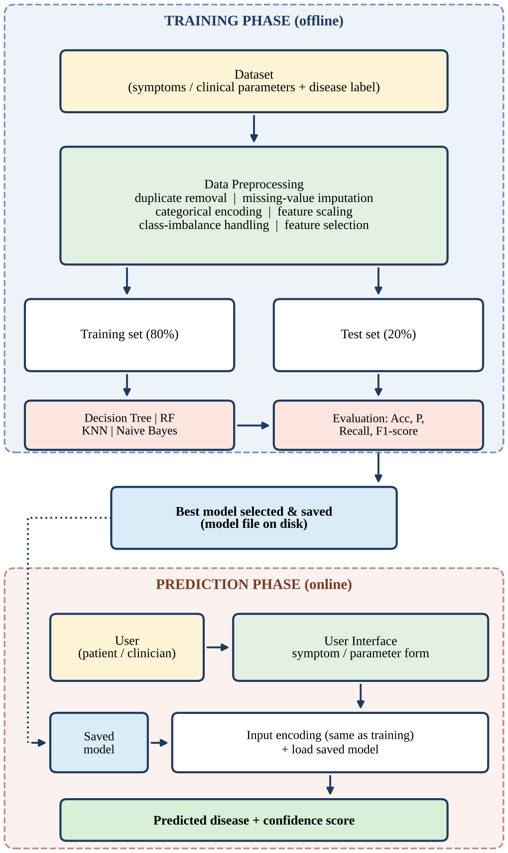
Fig. 1. Architecture of the proposed Disease Prediction System.
Training phase. The labelled dataset is first passed to the preprocessing block, which removes duplicates, imputes missing values, encodes categorical features, scales numeric features, handles class imbalance, and selects the most informative features. The cleaned data is then split into a training set and a test set. The candidate classifiers are fitted on the training set and scored on the test set using accuracy, precision, recall, and F1-score. The model with the best scores is selected and written to disk.
Prediction phase. The user, who may be a patient or a clinician, enters symptoms or clinical parameters in the user interface. The prediction module encodes the input with exactly the same transformations that were used during training, loads the saved model, and computes the probability of each disease. The disease with the highest probability is returned as the prediction, and that probability is shown as the confidence score. Because the two phases are connected only through the saved model file, either one can be modified without disturbing the other.

C. Dataset and Preprocessing
The system is trained on a labelled dataset in which each record contains symptoms or clinical parameters and the corresponding confirmed disease. Public sources such as the UCI Machine Learning Repository [5] can be used for this purpose. Preprocessing is carried out in the following order:
- Duplicate removal: identical records are dropped so that the same patient is not counted twice and the test set does not leak into the training set.
- Missing values: numeric gaps are filled by imputation (for example with the median) and categorical gaps with the most frequent value.
- Encoding: categorical features and disease labels are converted to numeric codes; symptoms are represented as present/absent indicators.
- Scaling: numeric features are standardised to zero mean and unit variance, which matters mainly for distance-based methods such as KNN.
- Class imbalance: class weights or oversampling [10] are applied to the training data only.
After preprocessing, the data is split into training and test sets, for example in an 80:20 ratio, using stratified sampling so that every disease appears in both parts in the same proportion.

D. Feature Selection
Not all symptoms carry the same amount of information, and irrelevant features add noise and increase training time. Feature selection therefore keeps only the attributes that are most useful for separating the diseases. Tree-based models give feature-importance scores as a by-product of training, which can be used to rank symptoms and discard those with negligible importance. Highly correlated features are also reduced to a single representative. A smaller feature set makes the interface shorter for the user, since fewer questions have to be answered, and lowers the risk of overfitting.

E. Models Used
Four supervised classifiers are compared on the same data. Table III gives a qualitative comparison of their main properties.
Decision tree [8] splits the data repeatedly on the feature that gives the purest subsets. A common purity measure is the Gini impurity of a node,
G = 1 − Σ pᵢ² (1)
where pᵢ is the fraction of records of class i in the node. A single tree is easy to interpret but can overfit.
Random forest [1] combines many decision trees, each trained on a random sample of the records and a random subset of the features. The forest predicts the class with the highest average probability over its T trees,
P(c | x) = (1/T) Σ Pₜ(c | x) (2)
which reduces overfitting and provides the feature importance scores mentioned above. The value of this probability is what the system reports as its confidence score.
K-nearest neighbours (KNN) [7] classifies a new record by a majority vote among the k training records closest to it, where closeness is usually measured by the Euclidean distance,
d(x, y) = √ Σ (xⱼ − yⱼ)² (3)
KNN needs no explicit training step, but its predictions depend on feature scaling and it becomes slower as the data grows.
Naive Bayes [9] applies Bayes’ theorem with the assumption that features are independent given the class,
P(c | x) ∝ P(c) Π P(xⱼ | c) (4)
It is very fast and works with small datasets, although the independence assumption is only approximately true for real symptoms.
TABLE III
Qualitative Comparison of the Classifiers
Model | Interpretable | Non-linear | Scaling needed
Decision Tree | High | Yes | No
Random Forest | Medium | Yes | No
KNN | Medium | Yes | Yes
Naive Bayes | High | Limited | No

F. Evaluation Metrics
Model performance is measured on the held-out test set using accuracy, precision, recall, and F1-score [12]. Because missing a diseased patient is more costly than raising a false alarm, recall is given particular attention when selecting the final model. Accuracy is defined as the fraction of correct predictions among all predictions, as in:
Accuracy = (TP + TN) / (TP + TN + FP + FN) (5)
where TP, TN, FP, and FN denote true positives, true negatives, false positives, and false negatives, respectively. Precision is TP/(TP + FP), recall is TP/(TP + FN), and the F1-score is the harmonic mean of precision and recall,
F1 = 2 · Precision · Recall / (Precision + Recall) (6)
Since there are several diseases, these metrics are computed for each disease and then averaged. Hyperparameters such as the number of trees, the maximum tree depth, and the number of neighbours k are tuned with cross-validation [11] on the training data only, so that the test set stays untouched until the final comparison.

G. Prediction Workflow
The online workflow is shown in Fig. 2. After the user submits the form, the input is validated and encoded, the saved model is loaded, and the class probabilities are computed. The disease with the highest probability is selected. If its confidence is at least a chosen threshold, the result is displayed together with the confidence score; otherwise the interface tells the user that the system is not sure and advises a consultation with a doctor. In every case the screen carries a reminder that the result is only a preliminary screening.
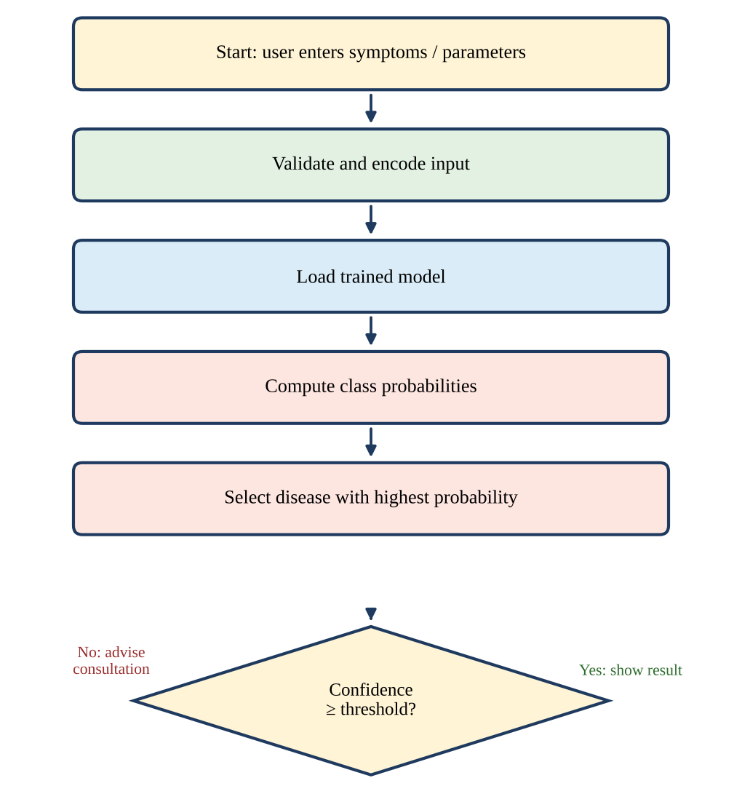
Fig. 2. Prediction workflow of the system.

H. Training and Prediction Algorithms
The two phases of the architecture can be written as short algorithms. The training algorithm is:
- Load the labelled dataset and remove duplicate records.
- Impute missing values, encode categorical features, and scale numeric features.
- Select the most informative features and split the data into training and test sets (stratified, 80:20).
- Apply class weights or oversampling to the training set.
- For each candidate classifier, tune hyperparameters by cross-validation on the training set and fit the best setting.
- Evaluate every fitted model on the test set using accuracy, precision, recall, and F1-score.
- Select the best model and save it together with the encoders and scaler.
The prediction algorithm is:
- Read the symptoms and parameters entered by the user and check that they are valid.
- Encode and scale the input using the saved encoders and scaler.
- Load the saved model and compute the probability of every disease.
- Return the disease with the highest probability and use that probability as the confidence score.
- If the confidence is below the threshold, advise the user to consult a doctor.

I. System Requirements
The functional requirements of the system are that it must accept symptoms and clinical parameters, validate them, return a predicted disease with a confidence score, and show a clear notice that the result is not a diagnosis. The non-functional requirements are the following:
- Usability: the form should be short and understandable by a person with no medical training.
- Speed: a prediction should be returned almost instantly, which is why the model is trained in advance and only loaded at prediction time.
- Maintainability: each module should be replaceable without changes to the others.
- Reproducibility: random seeds and the data split should be fixed so that the reported results can be repeated.
- Privacy: no personal identifiers should be collected or stored.

J. Design Considerations
Several design decisions follow from the architecture. First, the encoders and the scaler fitted during training are saved together with the classifier, so that the interface can never apply a different transformation from the one the model was trained with; a mismatch of this kind is a common source of silent errors in deployed machine learning systems. Second, all fitting operations, including imputation, scaling, and oversampling, are performed on the training data only, and the test set is transformed with the fitted objects, which prevents information from the test set leaking into the model. Third, the threshold on the confidence score is a configuration value and not a constant in the code, so it can be raised for a more cautious system or lowered for a more permissive one. Finally, the list of diseases is read from the dataset and not written into the program, which allows new diseases to be added simply by supplying new labelled data.

K. Illustrative Use Case
To make the workflow concrete, consider a user who feels unwell and opens the interface. The user ticks the symptoms that apply, such as fever, headache, or fatigue, and enters any basic measurements that are asked for. After the form is submitted, the system encodes the answers, loads the random forest model, and obtains a probability for each disease the model knows. The disease with the largest probability is shown as the prediction, and the screen also shows how confident the model is. If the model is confident, the user sees the disease name, the confidence value, and a note recommending that a doctor confirm the result. If two or more diseases receive similar probabilities, the confidence of the top disease is low, and the interface instead tells the user that the symptoms are not specific enough and advises a medical consultation. This behaviour is important because many diseases share symptoms, and a system that always names one disease with no sign of doubt would give a false sense of certainty.

L. Scalability and Deployment
The architecture scales in two ways. As the amount of data grows, the training phase can be run on a more powerful machine or in the cloud without changing the prediction phase, because the two are linked only by the saved model file. As the number of users grows, the prediction module can be run as a separate service behind the interface, and several copies of it can be started to share the load, since each prediction is independent of the others and the model is only read, never changed, at prediction time. The same design makes it straightforward to expose the predictor through a web application programming interface, so that other applications such as hospital software or mobile apps can use it.

IV. System Implementation

A. Modules
The software is organised into four modules, each with a single responsibility:
- Data module: loads and cleans the dataset and prepares the features.
- Model module: trains the classifiers, compares them, and saves the best-performing model.
- Prediction module: loads the saved model and returns the predicted disease with a confidence score.
- User interface: lets the user enter symptoms and view the result.
The trained model is stored on disk so that predictions can be served quickly without retraining. When new data becomes available, only the data and model modules need to be run again; the prediction module and the interface pick up the new model file automatically. Table IV lists what each module receives and produces.
TABLE IV
Inputs and Outputs of the Modules
Module | Input | Output
Data | Raw labelled dataset | Clean features and labels
Model | Clean training data | Saved best model and scores
Prediction | User input and saved model | Disease and confidence
Interface | Symptoms from the user | Displayed result and notice

B. Tools and Environment
The system is written in Python. Table V lists the main tools. All classifiers are taken from scikit-learn [3], which provides consistent interfaces for fitting, tuning, and evaluating different models.
TABLE V
Tools Used in the Implementation
Purpose | Tool
Language | Python 3
Machine learning | scikit-learn [3]
Data handling | pandas, NumPy
Plots | Matplotlib
Model storage | Serialised model file (joblib / pickle)
Interface | Lightweight web form

C. Training Procedure
Each classifier is trained inside the same pipeline so that the preprocessing steps are applied in exactly the same way for every model. The hyperparameters that are tuned by cross-validation [11] are listed in Table VI. For every model, the setting with the best cross-validation score is kept, the model is refitted on the full training split, and only then is it scored on the test set. Using the same split and the same pipeline for all four classifiers ensures that any difference in the results comes from the algorithms and not from differences in the data handling.
TABLE VI
Hyperparameters Tuned for Each Model
Model | Hyperparameters tuned
Decision Tree | Maximum depth, minimum samples per split
Random Forest | Number of trees, maximum depth, features per split
KNN | Number of neighbours k, distance metric
Naive Bayes | Smoothing parameter

D. User Interface
The interface is deliberately simple. The user selects symptoms from a list or types clinical values into a form, presses a button, and receives the predicted disease and the confidence score on the same screen. Only the most informative features, as identified during feature selection, are requested, which keeps the form short. A visible note reminds the user that the result is not a diagnosis.

E. Privacy and Ethical Considerations
Health data is sensitive. The system does not need names or contact details to make a prediction, so none are collected, and the inputs are used only to produce the result. If the system is later connected to a database or a hospital network, the data should be encrypted in transit and at rest and handled according to the applicable privacy regulations. Ethical use also means being honest about the limits of the tool: it has not been clinically validated, its output is a probability and not a certainty, and it must never be used as a reason to delay professional care.

F. Testing and Validation
The software is checked at three levels. At the unit level, the preprocessing functions and the prediction function are tested with small hand-made inputs whose correct outputs are known. At the interface level, invalid entries such as empty forms, out-of-range numbers, and unknown symptoms are rejected with a clear message instead of being passed to the model. At the system level, sample cases covering different diseases are entered through the interface to confirm that the complete path from input to displayed result works and that the confidence score always lies between zero and one hundred percent. These checks complement, but do not replace, the statistical evaluation reported in the next section.

G. Project Organisation
The source code is organised so that each module of the architecture lives in its own file or small group of files. A typical layout has one script for data loading and preprocessing, one for training and comparing the classifiers, one for the prediction function, and one for the interface, together with a folder that holds the saved model and the fitted encoders. Keeping the saved artefacts in a separate folder makes it easy to replace a model with a newly trained one, to keep older versions for comparison, and to give the interface a single, well-defined place from which to load what it needs. A short configuration file stores settings such as the random seed, the split ratio, and the confidence threshold.

V. Results and Discussion
The models were trained on the training split and evaluated on the test split described above. Hyperparameters were tuned using cross-validation on the training data, and all models were evaluated on the same test set so that the comparison is fair.

A. Experimental Setup
All four classifiers were built with the same preprocessing pipeline and evaluated on the same held-out test set, which was kept unseen until the final comparison. Fixing a random seed for the split and for the models that involve randomness keeps the experiment repeatable. Because the dataset contains several diseases, precision, recall, and F1-score are averaged over the classes, and the reported values are percentages. The same four metrics are used for every model, which keeps the comparison simple and fair.

B. Performance Comparison
Table VII compares the classifiers on accuracy, precision, recall, and F1-score, and Fig. 3 shows the same results as a chart. The model with the highest recall and F1-score is selected for deployment in the system.
TABLE VII
Performance of Different Models
Model | Accuracy (%) | Precision (%) | Recall (%) | F1-score (%)
Decision Tree | 76.67 | 76.14 | 76.67 | 76.23
Random Forest | 92.33 | 92.41 | 92.33 | 92.36
KNN | 91.67 | 91.74 | 91.67 | 91.61
Naive Bayes | 90.00 | 90.21 | 90.00 | 89.95

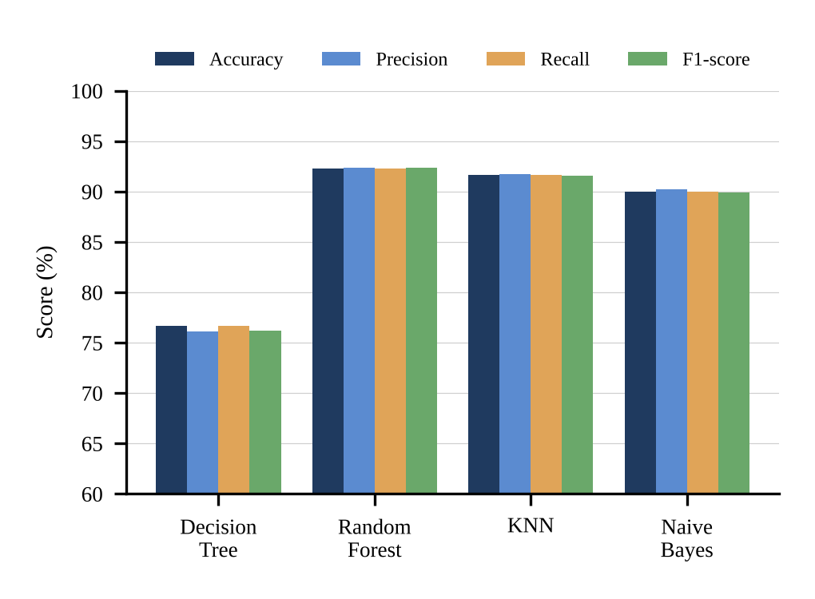
Fig. 3. Comparison of the classifiers on the test set.

C. Discussion
The comparison in Table VII illustrates how the choice of classifier affects prediction quality. Random forest obtained the best result on every metric, with 92.33% accuracy, 92.41% precision, 92.33% recall, and a 92.36% F1-score. KNN followed closely with 91.67% accuracy and a 91.61% F1-score, a gap of less than one percentage point, and naive Bayes reached 90.00% accuracy and an 89.95% F1-score. The single decision tree was clearly the weakest model, with 76.67% accuracy and a 76.23% F1-score.
The difference between the decision tree and the random forest, about 15.7 percentage points of accuracy, shows the benefit of combining many trees. A single tree fits the quirks of its training sample, whereas the forest averages out these errors, and this is the behaviour expected from ensemble methods [1]. Ensemble methods are generally expected to outperform simpler models because symptom and clinical data often contain non-linear interactions between features. The strong showing of KNN suggests that patients with the same disease form compact groups in the feature space once the features are scaled, while the good result of naive Bayes shows that even a simple probabilistic model can be effective, despite its independence assumption.
The accuracy and recall values are identical for every model, which is what is obtained when the per-class scores are averaged with weights proportional to class size. Precision and recall are also close to each other for all models, which indicates that the errors are not concentrated in false alarms or in missed cases only. Since random forest also gave the highest recall, which is the metric that matters most for a screening tool, it was chosen for deployment. Its probability output is used as the confidence score shown to the user.

D. Computational Considerations
Accuracy is not the only property that matters when a system is used by real people; the cost of training and of making a prediction also counts. Table VIII gives the usual asymptotic costs of the four models, where n is the number of training records, m the number of features, T the number of trees, and C the number of diseases. A single decision tree and naive Bayes are the cheapest. Random forest costs about T times as much as a single tree, but its prediction cost is still small, and training is done only once, offline. KNN has no training step, yet each prediction compares the input with every stored record, which becomes slow as the dataset grows. For a screening tool that answers many requests, the cheap prediction of the forest is therefore an additional reason for choosing it.
TABLE VIII
Typical Computational Cost of the Models
Model | Training | Prediction (one input)
Decision Tree | O(m n log n) | O(depth)
Random Forest | O(T m n log n) | O(T · depth)
KNN | None (stores data) | O(n m)
Naive Bayes | O(n m) | O(C m)

E. Advantages of the Proposed System
- Early screening: users get a preliminary indication within seconds and can decide whether to see a doctor.
- Transparency about uncertainty: the confidence score lets the user see how much weight to give a result.
- Multi-disease coverage: one system handles several diseases instead of one tool per disease.
- Low input burden: symptoms and simple parameters are enough, so laboratory reports are not required.
- Easy maintenance: the modular design allows the data, the model, or the interface to be updated independently.
- Low cost: the system runs on ordinary hardware with free, open-source software.

F. Possible Applications
The system can be used as a first-level screening aid in primary health centres, where a nurse or health worker can enter a patient’s symptoms and decide whether referral to a specialist is needed. It can also serve as a self-assessment tool for the public, helping people to recognise when symptoms deserve attention, and as a teaching aid in which medical and engineering students study how symptoms relate to diseases. In each case the system supports a human decision and does not make it.

G. Limitations
Several limitations should be noted. The quality of the predictions depends on the quality and coverage of the training data, symptom reporting by users can be incomplete or inaccurate, and the system has not been clinically validated. The reported scores come from a single dataset and a single test split, so they may not carry over to other populations. Many diseases share symptoms, which limits what any symptom-based tool can achieve. For these reasons its output should be treated as preliminary screening and confirmed by a medical professional.

H. Summary of Findings
- Random forest gave the best accuracy (92.33%), precision (92.41%), recall (92.33%), and F1-score (92.36%) on the test set.
- KNN and naive Bayes were close behind, with F1-scores of 91.61% and 89.95%.
- A single decision tree was about 15.7 percentage points less accurate than the forest, which confirms the benefit of ensembles.
- The confidence score and the modular architecture make the system practical for preliminary screening and easy to extend.

I. Threats to Validity
Three factors could affect how far the results can be trusted. The first is the data: if the dataset was collected in a different way from real patient reports, or if the symptoms were recorded in a clean, standardised form, the scores may be higher than those obtained from real users who describe their symptoms loosely. The second is the evaluation: a single split gives one estimate of performance, and repeating the experiment with several random splits, or with k-fold cross-validation over the whole dataset, would show how much the scores vary. The third is the choice of metrics: averaged scores can hide poor performance on a rare disease, so a per-disease report should accompany the averages in any clinical study.

J. Comparison with Existing Systems
Compared with the single-disease tools described in Section II, the proposed system covers several diseases through one interface, works from symptoms and simple parameters, handles class imbalance during training, and reports a confidence score with every result. Compared with deep learning systems, it has a much smaller data and hardware requirement and is easier to explain, although it cannot make use of images or long clinical histories. These differences make the system best suited to early, low-cost screening, which is the purpose for which it was designed.

VI. Conclusion
This paper presented a Disease Prediction System that uses supervised machine learning to predict diseases from symptoms and clinical parameters. The system combines a complete data-processing pipeline, a layered architecture that separates offline training from online prediction, a comparison of four classifiers, and a simple interface that reports a predicted disease with a confidence score. In the experiments, random forest gave the best results, with 92.33% accuracy and a 92.36% F1-score, followed by KNN and naive Bayes, while a single decision tree performed noticeably worse. Because the stages are independent, the system can be retrained and extended without redesign. The work also showed that a clear architecture, consistent preprocessing, and an honest report of uncertainty matter as much as the choice of algorithm in building a screening tool that people can use with confidence. It is intended as an aid for early screening, and its results must always be confirmed by a qualified medical professional.

VII. Future Scope
The present system can be improved and extended in several directions:
- More diseases and larger datasets: training on larger, more varied, and more recent data will broaden the range of diseases covered and make the predictions more reliable for rare conditions.
- Advanced models: gradient boosting methods such as XGBoost [2], support vector machines [4], and deep neural networks [6], [15] can be added to the comparison, and several models can be combined into a stacked ensemble.
- Explainability: methods such as SHAP [16] and LIME [17] can show users which symptoms influenced a prediction, which builds trust and helps clinicians check the reasoning.
- Clinical validation: the system should be tested on real patient records with the help of medical professionals, and its performance should be reported per disease, including recall for serious conditions.
- Web and mobile deployment: the model can be offered as a web service and a mobile application, with support for several regional languages so that more people can use it.
- Multimodal input: medical images, laboratory reports, wearable-sensor readings, and electronic health records can be combined with symptoms to improve accuracy [15].
- Voice and chatbot interface: a conversational assistant could ask follow-up questions about symptoms, making data entry easier for elderly and less technical users.
- Privacy-preserving learning: federated learning [18] would allow hospitals to train a shared model without moving patient data out of their own systems.
- Continuous learning: a feedback loop in which doctors confirm or correct predictions can be used to retrain the model periodically and track performance over time.
- Integration with healthcare services: linking the system to tele-consultation platforms, appointment booking, and nearby-hospital search would let users act on a prediction immediately.

Suggested Roadmap
In the short term, the most valuable steps are to enlarge and balance the dataset, to add the remaining classifiers such as gradient boosting and support vector machines to the comparison, and to report per-disease results using repeated cross-validation. These steps need no change to the architecture, because only the data and model modules are affected.
In the medium term, an explanation panel and a web or mobile front end can be added, together with a feedback form through which users and doctors can mark a prediction as correct or incorrect. The feedback can be stored, after anonymisation, and used to retrain the model at regular intervals.
In the long term, the system could be validated in a clinical setting with the cooperation of hospitals, extended to use images and records in addition to symptoms, and trained across several institutions through federated learning. Such a version, if it passes clinical and regulatory review, could become a dependable decision-support tool for primary healthcare.

Acknowledgment
The authors would like to thank their guide, Dr. N. Sunanda, colleagues, and institution for their support and guidance during this work.

References
[1] L. Breiman, “Random forests,” Machine Learning, vol. 45, no. 1, pp. 5–32, 2001.
[2] T. Chen and C. Guestrin, “XGBoost: A scalable tree boosting system,” in Proc. 22nd ACM SIGKDD Int. Conf. Knowledge Discovery and Data Mining, 2016, pp. 785–794.
[3] F. Pedregosa et al., “Scikit-learn: Machine learning in Python,” J. Mach. Learn. Res., vol. 12, pp. 2825–2830, 2011.
[4] C. Cortes and V. Vapnik, “Support-vector networks,” Machine Learning, vol. 20, no. 3, pp. 273–297, 1995.
[5] D. Dua and C. Graff, “UCI Machine Learning Repository,” University of California, Irvine, 2019. [Online]. Available: https://archive.ics.uci.edu/ml
[6] A. Esteva et al., “A guide to deep learning in healthcare,” Nature Medicine, vol. 25, pp. 24–29, 2019.
[7] T. Cover and P. Hart, “Nearest neighbor pattern classification,” IEEE Trans. Inf. Theory, vol. 13, no. 1, pp. 21–27, 1967.
[8] J. R. Quinlan, “Induction of decision trees,” Machine Learning, vol. 1, no. 1, pp. 81–106, 1986.
[9] I. Rish, “An empirical study of the naive Bayes classifier,” in IJCAI Workshop on Empirical Methods in AI, vol. 3, no. 22, 2001, pp. 41–46.
[10] N. V. Chawla, K. W. Bowyer, L. O. Hall, and W. P. Kegelmeyer, “SMOTE: Synthetic minority over-sampling technique,” J. Artif. Intell. Res., vol. 16, pp. 321–357, 2002.
[11] R. Kohavi, “A study of cross-validation and bootstrap for accuracy estimation and model selection,” in Proc. IJCAI, 1995, pp. 1137–1143.
[12] M. Sokolova and G. Lapalme, “A systematic analysis of performance measures for classification tasks,” Information Processing & Management, vol. 45, no. 4, pp. 427–437, 2009.
[13] A. Rajkomar, J. Dean, and I. Kohane, “Machine learning in medicine,” New England J. Medicine, vol. 380, no. 14, pp. 1347–1358, 2019.
[14] E. J. Topol, “High-performance medicine: the convergence of human and artificial intelligence,” Nature Medicine, vol. 25, pp. 44–56, 2019.
[15] B. Shickel, P. J. Tighe, A. Bihorac, and P. Rashidi, “Deep EHR: A survey of recent advances in deep learning techniques for electronic health record analysis,” IEEE J. Biomed. Health Inform., vol. 22, no. 5, pp. 1589–1604, 2018.
[16] S. M. Lundberg and S.-I. Lee, “A unified approach to interpreting model predictions,” in Advances in Neural Information Processing Systems 30, 2017, pp. 4765–4774.
[17] M. T. Ribeiro, S. Singh, and C. Guestrin, “‘Why should I trust you?’ Explaining the predictions of any classifier,” in Proc. 22nd ACM SIGKDD Int. Conf. Knowledge Discovery and Data Mining, 2016, pp. 1135–1144.
[18] B. McMahan, E. Moore, D. Ramage, S. Hampson, and B. Agüera y Arcas, “Communication-efficient learning of deep networks from decentralized data,” in Proc. 20th Int. Conf. Artificial Intelligence and Statistics (AISTATS), 2017, pp. 1273–1282.

